**Lab Manual 6**

**Lab Tasks**

**Program 1:**

Program //Program for Fibonacci Series

#include <iostream>

Using namespace std;

Int main()

{

Int n,temp,a=0,b=1;

//n is the user input number of terms

Cout<<”Enter no. Of terms”<<endl;

Cin>>n;

Cout<<a<<” “;

Cout<<b<<” “;

For(int count=1; count<=(n-2) ; count++)

{

Temp=b;

B+=a;

A= temp;

Cout<< b<<” “;

}

Return 0;

}

**Output:** 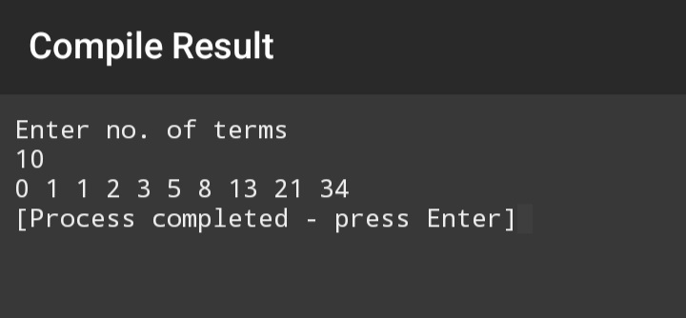

**Program 2:**

//Program to make Floyd's Triangle

#include<iostream>

using namespace std;

int main(){

int n,sum=1;

//n is the user input number of rows

cout<<"Enter the number of rows for your Floyd's Triangle"<<endl;

cin>>n;

for (int i=1;i<=n;i++) //i controls the number rows in Floyd's Triangle

{

for (int j=1;j<=i;j++) //j controls spacing in-between rows and number display

{

cout<<sum<<" ";

sum++;

}

cout<<endl;

}

}

**Output:**

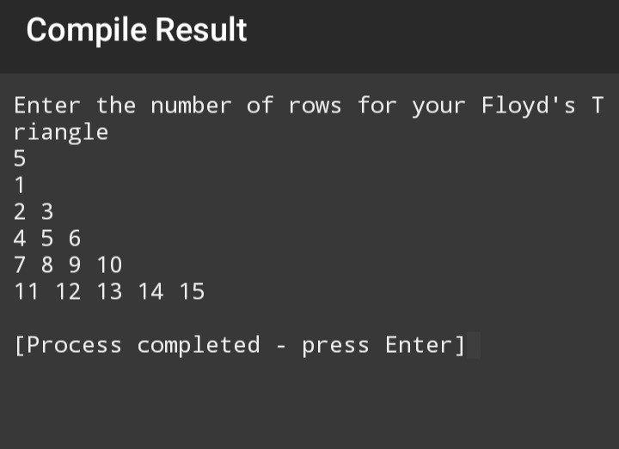

**Hometasks:**

**Program 1:**

//Program to print sum of Prime Numbers from 1 to 50

#include<iostream>

using namespace std;

int main()

{

int n=2,sum=0;

bool prime_n;

while (n<=50)

{

bool prime_n=true;

for (int i=2; i<=n/2; i++)

{

if (n%i==0)

{

prime_n=false;

break;

}

}

if (prime_n)

{

sum+=n;

}

n++;

}

cout<<"The sum of Prime Numbers from 1 to 50 is "<<sum<<endl;

}

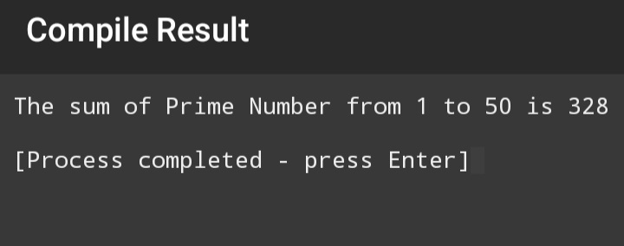**Output**:

**Program 2:**

#include<iostream>

using namespace std;

int main()

{

int n; //n is the user input number of rows

cout<<"Enter the number of rows for the pattern."<<endl;

cin>>n;

for (int i = 1; i <=n; i++)

{

for (int j = 1; j <= i; j++)

{

cout << j << " ";

}

cout << endl;

}

return 0;

}

**Output:** 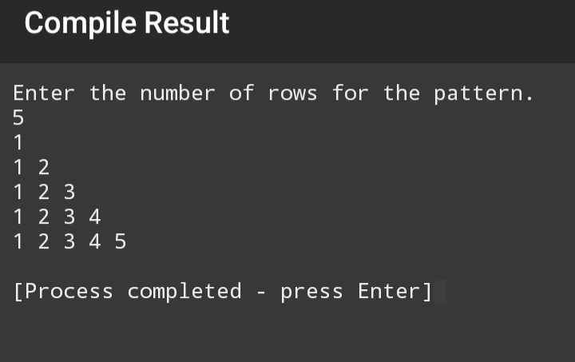

**Program 3:**

#include<iostream>

using namespace std;

int main()

{

cout<<"1"<<endl;

for (int i = 1; i <=6; i += 1)

{

for (int j = 1; j <= i; j++)

{

if (i%2!=0)

continue;

cout << i << " ";

}

cout << endl;

}

return 0;

}

**Output:**

